Resources for March 1, 2024 Online Handheld Finger Labyrinth Walk

With Judith Tripp and Ruth Cunningham
On the theme: We are the World

Ruth’s song
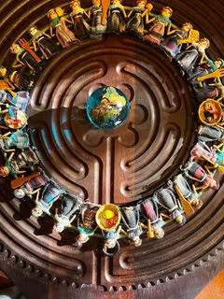
Then I was standing on the highest mountain of them all, and round about beneath me was the whole hoop of the world. And while I stood there, I saw more than I can tell and I understood more than I saw; for I was seeing in a sacred manner the shapes of all things in the spirit, and the shape of all shapes as they must live together like one being. And I saw the sacred hoop of my people was one of the many hoops that made one circle, wide as daylight and as starlight, and in the center grew one mighty flowering tree to shelter all the children of one mother and one father. And I saw that it was holy. ... But anywhere is the center of the world.

~ Black Elk, Oglala Sioux (1863-1950)

